Dear prospective MESA steward,

Thanks for your interest in working at Dripping Springs Garden. This coming season (2018) will be the 34th summer of production for us here--amazing how deeply rooted we’ve become. And for most of those summers, we’ve hosted numerous young people in the garden, here to help plant, weed, water, harvest, and market the crops. It’s a great, mutually beneficial relationship, and we’ve made many life-long friends because of our time spent together working. This letter is an attempt to describe what to expect as, and what is expected of, our garden apprentices.

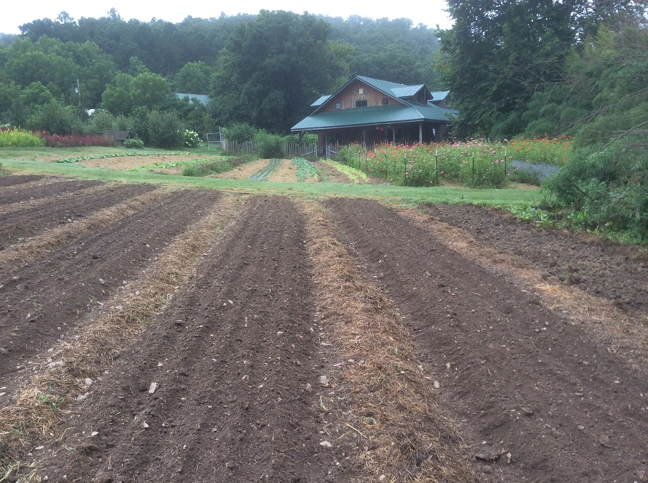

Apprentices generally will arrive between early March and early April of the production year and stay until late October-- a 6-7 month period. We like to have an early team coming in the first or second week of March, and try to have everyone arrive by the first week of April if possible. It’s still relatively cold in March, with frosty mornings but often mild days. We are busy then with greenhouse propagation and hoophouse plantings, and we set out our first outdoor plantings of cool-season greens.

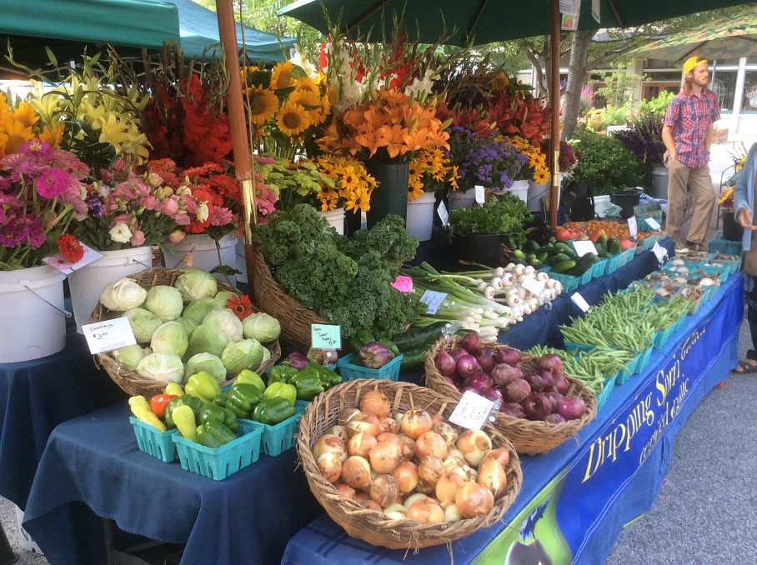

The first weekend in April, the Farmers Market on the Square in Fayetteville begins. We attend this market 3 times per week, on Tuesdays, Thursdays, and Saturday mornings. That means we harvest on Mondays, Wednesdays, and Fridays for the following day’s market. Weekday markets are attended by either Mike, Mark, or a seasoned intern; and usually everyone on our apprentice team goes to Saturday market with Mark. It’s an early day: we load the truck at 3:45 a.m. and take off for Fayetteville at 4:15, arriving before 5:30 to unload and set up our display. The market opens at 7:00 a.m., and we start to shut down a bit after 1:00 p.m., reloading the truck before heading to a local restaurant for lunch. Market day is fun and exciting even though it’s a bit tiring! We see lots of old friends, make new ones, and work like mad making bouquets and selling veggies to the public. Market provides a first-class education in what the public wants to buy, and an opportunity to educate customers about our products and organics in general. We also get to see what all the other producers have, and enjoy our camaraderie with them.

Our Community Supported Agriculture (CSA) program begins mid-May and extends through mid-October. Households in the Fayetteville area subscribe to a full season’s worth of box deliveries every week, delivered on Thursday mornings at a single location on our way to the Farmers Market. Each box (we have 2 sizes) contains the best selection we have at that time from the garden. We keep in touch with our subscriber group via a weekly newsletter that contains stories of farm life, descriptions of the box contents, and helpful recipes. We harvest for both the CSA and the Farmers Market on Wednesday mornings, and often have the CSA boxes packed and in the cooler before lunch break.

We also currently grow for two other accounts, Ozark Natural Foods (an organic grocery store in Fayetteville) and The Farmer’s Table (a Fayetteville restaurant specializing in serving dishes that use locally-grown ingredients).

By mid-summer, the garden is bursting forth with all kinds of veggies, flowers, and herbs. We actually produce about 50% veggies and 50% cut flowers, and we are well-known in the area for our quality cut flowers. Prospective brides contact us for bridal bouquets, boutonnieres, table arrangements, and more; for several years there has been great interest in locally-grown flowers for weddings. We also produce bouquets for special events and informal parties, so keeping up a steady supply of blooms as well as vegetables contributes to the financial health of the farm.

During the course of a typical summer, we’ll have a few public tours of the garden, and several informal ones as well: Master Gardeners groups, visiting farmers and interns, staff of the natural foods store….Often these are on Sundays, scheduled well in advance so that we can have everything looking great for the special guests.

By mid-October we usually have our first killing frosts, which end the warm-season crops outdoors but do not harm the cool-season greens and crops in the hoophouses. We start our cleanup, mowing down spent crops and planting cover crops, or planting over-wintering crops like garlic or tulips. October is a busy month, between the cleanup effort and planting of winter crops in the hoophouses and outdoors. Our weekday Farmers Markets on the Square in Fayetteville finish up the end of October, with only Saturdays in November. For the remainder of the winter before the Square market opens again, we continue to market once-weekly from our hoophouses to Ozark Natural Foods and The Farmers Table.

**GARDEN WORK SCHEDULE**

Our farm work schedule varies with the season somewhat, but will average 40 hours per week, plus market on Saturday. Work days may be somewhat shorter in cooler spring weather and longer as summer comes on.

Our general early-season work schedule Monday-Friday (Saturdays are at market) looks like:

8:00 breakfast

8:30 – 1 p.m. morning work (11:00 snack break)

1-3:00 p.m. yoga/afternoon break

3:00 lunch

3:30 or 4:00 p.m. to 6:30 or 7:00 p.m. afternoon work

**Main Season**

7:00 breakfast

7:30 a.m. – 1 p.m. morning work (11:00 snack break)

1:00 p.m.-3:00 p.m. yoga or free time

3:00 p.m. lunch

3:30 to 4:00 (depends on temperature) until 7 p.m. --afternoon work

As the weather gets warmer by early summer, we will need to start at 7 a.m. and take a longer lunch break so the flowers and veggies can be harvested at peak freshness.

**HOUSING**

Apprentice housing is either in the student rooms upstairs in the barn (2), in yurts near the garden (2), or in our new intern guest house (4). The barn rooms have electricity and small electric heaters for the chilly months. The yurts do not have electricity, but have small wood stoves for heat. The new guest house is fully equipped with 2 bathrooms, kitchen, dining room, and common space. There is also a student shower in the bathroom next to the walk-in cooler on the ground floor of the barn.

In the past few years almost all interns have had cell phones, so there is no longer a land line in the cabin; cell signals are weak down here in the valley and it’s easier to make a call by walking or driving up the driveway a bit (texts are often possible, though). Our internet service is via satellite, and is slower than town cable service: great for emails, bad for streaming.

We share meal preparation for breakfast and lunch in the guest house by having a rotating cooking schedule. Most of us will cook 1-2 days per week for the group. Household chores, including collecting recyclables, taking out the compost, cleaning the cabin, shower room, etc., are also scheduled into our weekly work so that our life as a community is clean and enjoyable.

Apprentices receive a monthly stipend plus room and board, and as so are a cross between employees and students. We take care to train everyone in as many aspects of the production as is possible, and then expect that as the summer progresses everyone will pick up speed and efficiency as they gain experience. Our farm is supported 100% by the sale of the garden’s production, from which all stipends and operating capital comes. Becoming a market gardener means paying attention to how to do jobs quickly and well, and staying focused on the priorities at hand.

For MESA students, the monthly stipend is $425/month. Checks are written every two weeks.

Besides the on-farm learning of production skills and the exposure to the Farmers Market on Saturdays, we try to arrange several field trips during the season to area farms, often trading a couple of hours work for a tour of their operation. In this way we’re able to both help out and learn from other producers, and gain valuable perspective.

**Living Together as a Community and the Art of Mindful Farming**

No doubt about it, living together as a harmonious community during the season, sharing daily work with the same partners day after day….this is some of the most important and sometimes difficult work we do. Not only do we have to be ready to work in any kind of weather, but it takes discipline to get up early and work all day, day after day, and still offer a smile to our co-workers. We can get tired, impatient, cross, hungry, elated, boisterous, sleepy……And yet the garden keeps growing, must be watered, crops harvested, and the marketing cycle continues. It is a challenging lifestyle—extremely rewarding when done well, but challenging nonetheless

*The Importance of Shared Values*

 We try achieve a balance between work and self-cultivation, and to organize the work well enough to include time for good meals, adequate rest, and the pursuit of personal endeavors. In this business it means having great focus and discipline, and the ability to let go of worry. Speed and efficiency are important, but they are not everything. Our ability to enjoy the work as we go about the necessary tasks is a skill in itself. In fact, our enjoyment and communion with each other and Nature are what has kept us farming for so many years.

.

We ask our interns to refrain from using iPods during our workdays together and not to bring cell phones to meals, in order to be fully available and to really tune-in to the garden and each other.

Morning Sitting and Check In

Though we’ve gotten pretty good about organizing the garden work with rotating flower and vegetable harvest teams, prioritizing work lists, etc., it’s important to know how we can support and understand each other as we go about the work. A morning check in before the work gets started gives us each a chance to share with the group a little bit of joy or suffering as it comes up for us. We might have to overcome a bit of shyness, but if we all make it alright for each other to do so, the group dynamic will be much more understanding and strong. We sit together briefly in quiet meditation for 5 minutes or so at the start of our morning work period, then invite everyone to check in with the group before heading to our various tasks.

Getting enough rest at night and on the weekends is important! The steady cultivation of yoga can really ease the strain on knees and backs.

.